A MINI PROJECT REPORT ON

**“Circumferential Reporting System”**

SUBMITTED BY:

**Abhijit Turate: 70**

**Priyanka Shinde: 71**

**Kesha Mehta: 74**

UNDER THE GUIDANCE OF:

**Prof. Suchetadevi Gaikwad**



Department of Information Technology

Atharva College of Engineering

Malad (W), Mumbai-400095

UNIVERSITY OF MUMBAI

2020-2021

Atharva College of Engineering

Malad (W), Mumbai-400095

**CERTIFICATE**

This is to certify that the project entitled **“Circumferential Monitoring System”** is a bonafide work of **Abhijit Turate, Priyanka Shinde, Kesha Mehta** submitted to the University of Mumbai in partial fulfilment of the requirement for the award of the degree of **“TE IT”** in **“Information Technology”**.

-------------------------

Internal Guide

(Prof.  Suchetadevi Gaikwaad

-------------------------                                                -------------------------

Internal Examiner                                                  External Examiner

--------------------------                                             ---------------------------

    Head of Department                                                       Principal

         (Prof. Deepali Maste)                                             (Dr. S. P. Kallurkar )

**MINI PROJECT APPROVAL CERTIFICATE**

This project report entitled “Circumferential Reporting System", by Abhijit Turate, Priyanka Shinde, Kesha Mehta are approved for the degree of Bachelor of Engineering in Information Technology.

                                                                        Examiners

1. ------------------------------------------------

1. ------------------------------------------------

Guides

1. ------------------------------------------------

2. ------------------------------------------------

Date:

Place: Malad (W), Mumbai-400095

**DECLARATION**

I declare that this written submission represents my ideas in my own words and where others' ideas or words have been included, I have adequately cited and referenced the original sources. I also declare that I have adhered to all principles of academic honesty and integrity and have not misrepresented or fabricated or falsified any idea/data/fact/source in my submission. I understand that any violation of the above will be cause for disciplinary action by the Institute and can also evoke penal action from the sources which have thus not been properly cited or from whom proper permission has not been taken when needed.

-----------------------------------------

                                                                           ABHIJIT TURATE

         (Roll No. 70)

-----------------------------------------

 PRIYANKA SHINDE

  (Roll No.71)

-----------------------------------------

   KESHA MEHTA

 (Roll No.74)

Date:

Place: Malad(West),Mumbai.

**ACKNOWLEDGEMENTS**

I have great pleasure in presenting the report on Circumferential Reporting System I take this opportunity to express my sincere thanks towards my guide Prof. Suchetadevi Gaikwad for providing the technical guidelines and the suggestions regarding the line of this work. I would like to express my gratitude towards her constant encouragement, support and guidance throughout the development of the project.

I am grateful to Dr. S. P. Kallurkar (Principal), Prof. Deepali Maste (HOD, Information Technology Engineering), without their support and advice our project would not have shaped up as it has.

I wish to express my deep gratitude towards all my colleagues at ACE, Mumbai for their encouragement.

Abhijit Turate

Priyanka Shinde

Kesha Mehta

**ABSTRACT**

The system proposed is a circumferential reporting system for monitoring the weather conditions at a particular place and make the information visible about the day. The technology behind this is Internet of Things (IoT), which is an advanced and efficient solution for connecting the things to the internet and to connect the entire world of things in a network. Here things might be whatever like electronic gadgets, sensors and automotive electronic equipment. The system deals with monitoring and sensing the environmental conditions like temperature, relative humidity and CO level with sensors and displays the information using lcd’s and led’s. The data updated from the implemented system can be accessible in the internet from anywhere in the world.

|  |  |  |  |  |  |  |  |  |  |  |  |  |  |  |  |  |  |  |  |  |  |  |  |  |  |  |  |  |  |  |  |  |  |  |  |  |  |  |  |  |  |  |  |  |
| --- | --- | --- | --- | --- | --- | --- | --- | --- | --- | --- | --- | --- | --- | --- | --- | --- | --- | --- | --- | --- | --- | --- | --- | --- | --- | --- | --- | --- | --- | --- | --- | --- | --- | --- | --- | --- | --- | --- | --- | --- | --- | --- | --- | --- |
| |  |  |  | | --- | --- | --- | | Sr No: | Title | Page No: | | 1. | INTRODUCTION |  | | 1.1 | Introduction | 6 | | 1.2 | Motivation | 7 | | 1.3 | Problem Statement | 8 | | 1.4 | Aims and Objectives | 9 | | 2. | LITERATURE SURVEY | 10 | | 3. | BLOCK DIAGRAM | 11 | | 4. | COMPONENTS | 13 | | 5. | RESULTS |  | | 5.1 | Circuit Diagram | 14 | | 5.2  5.3 | Code  Implementation | 16  17 | | 6. | CONCLUSIONS | 18 | | 7. | REFERENCES | 19 | |  |  |

**1.INTRODUCTION**

* 1. **Introduction**

We are living in an age where tasks and systems are fusing together with the power of IOT to have a more efficient system of working and to execute jobs quickly! With all the power at our fingertips this is what we have come up with. Building a general architecture for the IoT is hence a very complex task, mainly because of the extremely large variety of devices, link layer technologies, and services that may be involved in such a system. This project can be implemented in mainly 2 scenarios: 1. At Chemical Manufacturing Plants: MQ2 gas sensor detects gases like Methane, Butane, LPG and smoke. These gases can be detected and hence the buzzer is active indicating that there has been a leak. As these manufacturing plant operate with toxic substances, accidents may occur and appropriate reporting system must be in place to avoid health complications of workers as well as masses living in the nearby area. Hence a gas leak can be detected, the temperature may rise in case of any combustion related to a leak this can be detected by a temperature sensor. The combustion may lead to fire and the photoresistor can be used to indicate the presence of a fire. 2. Conditions for Outdoor Activity: For people who are more inclined to go outside for a walk or workout this system can be helpful in the following ways: Another variant of a gas sensor MQ135 can be used to check for the quality of air present in the nearby area. The gas sensor may be coupled with a temperature sensor to give the user accurate readings about the condition's outside. Finally, the photoresistor may indicate the presence or absence of sunlight which may improve and ultimately help the decision-making process of preferring activities outdoors as compared to indoors.

* 1. **Motivation**

Climatic change and environmental monitoring have received much attention recently. Man wants to stay updated about the latest weather conditions of any place like a college campus or any other particular building. Since the world is changing so fast so there should be the weather stations. Here in this paper we present a weather station that is very helpful for any places. This weather station is based on IOT (internet of things). It is equipped with environmental sensors used for measurements at any particular place and report them in real time on cloud. To accomplish this we used Arduino Uno and different environmental sensors like DHT11, soil moisture sensor and rain drop sensor .The sensors constantly sense the weather parameters and keeps on transmitting it to the online web server over a wifi connection.

* 1. **Problem Statement**

IoT Based Weather System acts as Weather Station and it update the Data Centre in Cloud. So, by using IoT Based Weather monitoring System we can solve the cost of equipment problem and also, we can also access the information remotely through internet Devices and Websites. The weather monitoring system provides only the present condition of a particular field which will not provide the exact condition of the particular city or particular place. The main problems in ordinary method were that devices are very much expensive and don’t have that much data measuring accuracy. In case of any divergent there is no such device to give the alert signal about current situation hence it’s very hard to control that kind of abnormality.

* 1. **Aims and objectives**
* The main objective is to develop a sustainable weather reporting system.
* This system will have sensors which will indicate when threshold is the most.
* This system will then automatically display the type of day with help of sensors.
* We can use this system in more than one way.

**2.LITERATURE SURVEY**

|  |  |  |  |  |
| --- | --- | --- | --- | --- |
| **Sr No:** | **Title** | **Author** | **Publication** | **Approach** |
| **1.** | Smart weather monitoring and real time alert system using IoT | Yashaswi Rahut , Rimsha Afreen, Divya Kamini | IJERT | The system proposed is an advanced solution for weather monitoring that uses IoT to make its real time data easily accessible over a very wide range. The system deals with monitoring weather and climate changes like temperature, humidity, wind speed, moisture, light intensity. |
| **2.** | IOT Based Weather Monitoring and Reporting System Project | Anita M. Bhagat, Ashwini G. Thakare,  Kajal A. Molke, Neha S. Muneshwar,  Prof. V. Choudhary | IJTSRD | The IOT based Weather Monitoring and Reporting System project is used to get Live reporting of weather conditions. It will Monitor temperature, humidity, moisture and rain level. Suppose Scientists/nature analysts want to monitor changes in a particular environment like volcano or a rain-forest. |
| **3.** | IOT based weather reporting system to find dynamic climatic parameters | Kavya Ladi,  A V S N Manoj,  G V N Deepak. | IEEE | Now-a-days many weather reporting applications are available which gives us information about climatic changes that are going to take place by which man can be aware of present and future climatic changes. Most of the weather reporting applications extracts the data from accurate weather system. |

**3.BLOCK DIAGRAM**

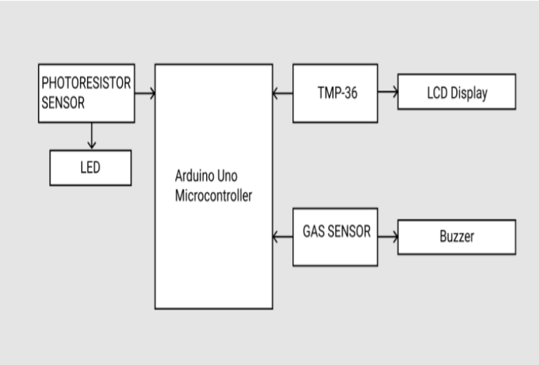

**4.COMPONENTS**

* **TMP36 sensor**

These sensors use a solid-state technique to determine the temperature. That is to say, they don't use mercury (like old thermometers), [bimetalic strips](http://en.wikipedia.org/wiki/Bimetallic_strip) (like in some home thermometers or stoves), nor do they use [thermistors (](http://en.wikipedia.org/wiki/Thermistor)temperature sensitive resistors). Instead, they use the fact as temperature increases, the voltage across a diode increases at a known rate. It has a temperature range of -40°C to 150°C / -40°F to 302°F and has three pins namely analog voltage in, analog voltage out and ground.

* **Photoresistor sensor**

Photoresistors, also known as light dependent resistors (LDR), are light sensitive devices most often used to indicate the presence or absence of light, or to measure the light intensity. In the dark, their resistance is extremely high, sometimes up to 1MΩ, but when the LDR sensor is exposed to light, the resistance drops dramatically, even down to a few ohms, depending on the light intensity.

* **Gas Sensor**

A gas sensor is a device which detects the presence or concentration of gases in the atmosphere. Based on the concentration of the gas the sensor produces a corresponding potential difference by changing the resistance of the material

inside the sensor, which can be measured as output voltage. Based on this voltage value the type and concentration of the gas can be estimated. It has 4 main pins, Vin, ground, digital output (this pin gives an output either in logical high or logical low (0 or 1) that means it displays the presence of any toxic or combustible gases near the sensor) and analog output (This pin gives an output continuous in voltage which varies based on the concentration of gas that is applied to the gas sensor). There are different versions of this sensor depending on the application one wants to implement. In our case the sensor used is MQ-7 that detects the presence of Carbon Monoxide

* **LCD Display**

* **LED**
* **Buzzer**
* **Arduino Uno Board**
* **Jumper cables**

**5.RESULTS**

**5.1 Circuit Diagram**

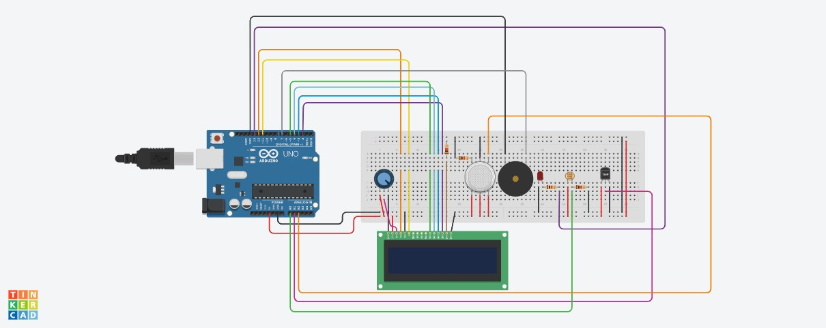

Before Simulation

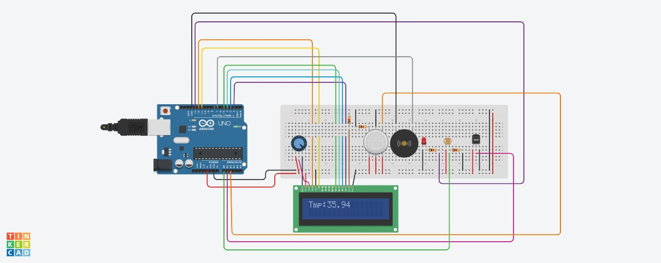

During Simulation

**5.2 Code**

#include <LiquidCrystal.h>

// initialize the library with the numbers of the interface pins

LiquidCrystal lcd(12, 11, 5, 4, 3, 2); float value; int tmp = A1; const int ledPin = 13; //the number of the LED pin const int ldrPin = A0; //the number of the LDR pin int v_GasSen = 0;

void setup() {

//TMP36

pinMode(tmp,INPUT);

//Photoresistor Serial.begin(9600); pinMode(ledPin, OUTPUT); //initialize the LED pin as an output pinMode(ldrPin, INPUT); //initialize the LDR pin as an input

//Gas Sensor pinMode(A2, INPUT);

pinMode(7, OUTPUT);

}

void loop() {

//TMP36

value = analogRead(tmp)* 0.00482814;

value =(value - 0.5) * 100.0; lcd.setCursor(0, 1); lcd.print("Tmp:"); lcd.print(value); delay(1000);

lcd.clear();

//Photoresistor

int ldrStatus = analogRead(ldrPin); //read the status of the LDR value if (ldrStatus <=300)

{

digitalWrite(ledPin, HIGH); //turn LED on

Serial.println("LDR is DARK, LED is ON");

} else {

digitalWrite(ledPin, LOW); //turn LED off

Serial.println("---------------");

}

//Gas Sensor

v_GasSen = analogRead(A2); if (v_GasSen >= 250)

{

tone(7, 523, 1000); // play tone 60 (C5 = 523 Hz)

}

delay(10); // Delay a little bit to improve simulation performance }

**5.3 Implementation**

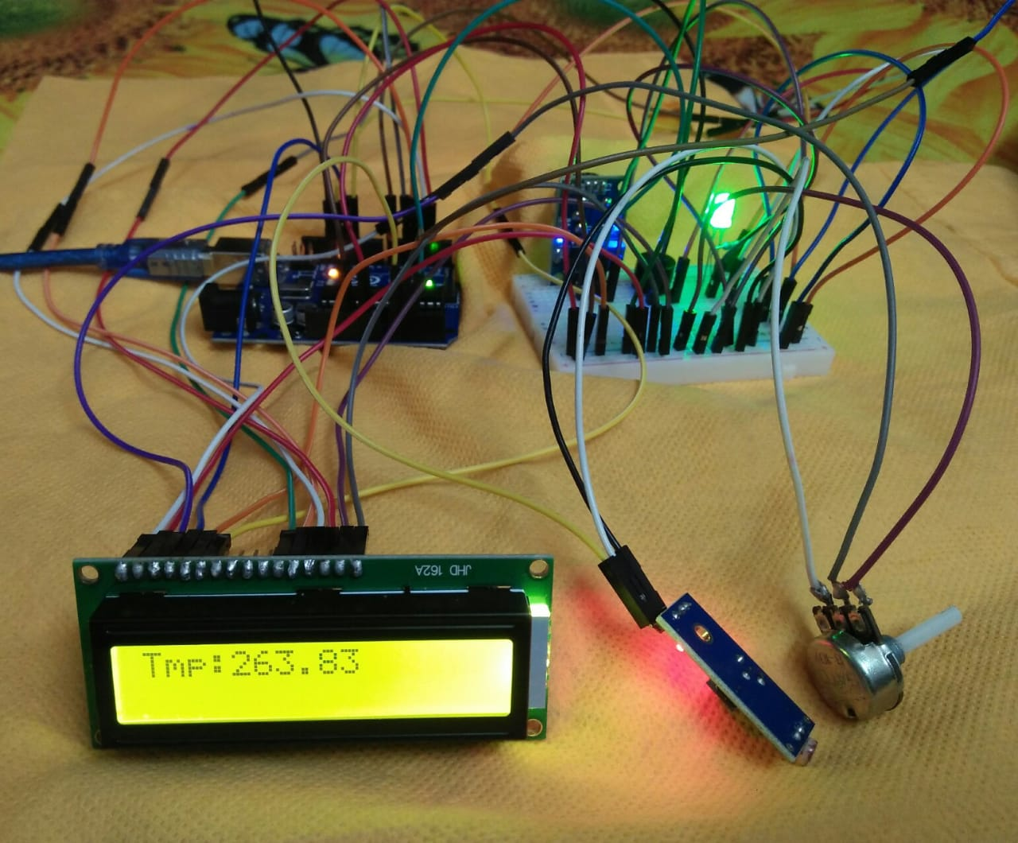

**Final Implementation**

**6. CONCLUSION**

We built an efficient Circumferential Reporting System which can be used to monitor the level temperature around. This project work is the implementation of Circumferential reporting system using Ultrasonic sensor, Arduino Uno, LED. This system assures the reporting of outside temperature to a point. This data can be further used to display the type of day it is and also its temperature. It ultimately helps to keep in the society as it is cost affective. Therefore, Circumferential reporting system is very effective.

**7.REFERENCES**

* K. Ladi, A. V. S. N. Manoj and G. V. N. Deepak, "IOT based weather reporting system to find dynamic climatic parameters," 2017 International Conference on Energy, Communication, Data Analytics and Soft Computing (ICECDS), 2017, pp. 2509-2513, doi: 10.1109/ICECDS.2017.8389904.
* Yashaswi Rahut 1, Rimsha Afreen2, Divya Kamini, “Smart weather monitoring and real time alert system using IoT” International Research Journal of Engineering and Technology (IRJET) e-ISSN: 2395-0056 Volume: 05 Issue: 10 | Oct 2018 www.irjet.net p-ISSN: 2395-0072
* Anita M. Bhagat, Ashwini G. Thakare, Kajal A. Molke, Neha S. Muneshwar, Prof. V. Choudhary "IOT Based Weather Monitoring and Reporting System Project" Published in International Journal of Trend in Scientific Research and Development (ijtsrd), ISSN: 2456- 6470, Volume-3 | Issue-3, April 2019, pp.365-367